# COMPUTER VISION ENGINEER TEST

*Examinee: Nguyễn Hoàng Long*

*Duration: 27/7/2024 – 29/7/2024*

*Github:* [*https://github.com/WalterNg/Fruits-Detection-App*](https://github.com/WalterNg/Fruits-Detection-App)

## Test Description

Develop a mobile application that performs object detection on a custom object of your choice. The application should be able to:

* **Detect and Identify the Custom Object:** Implement a model to detect and recognize a specific custom object in real-time using the device's camera.
* **Real-time Processing:** Ensure the detection runs in real-time with a reasonable frame rate on a standard mobile device.
* **User Interface:** Design a simple and intuitive user interface that displays the camera feed and highlights the detected object with a bounding box.
* **Documentation:** Provide a brief report explaining the methodology used, the choice of model, any preprocessing steps, and how the application was tested.

## Define Topic and Scope

Under the condition of developing and testing from home, fruits represent the most common and convenient subjects for training and testing stages. Consequently, I have selected fruits as the objects of interest. The dataset can be downloaded via the following link: <https://www.kaggle.com/datasets/lakshaytyagi01/fruit-detection>

Here are the brief summary about the dataset:

* The dataset includes 8479 images of 6 different fruits (Apple, Grapes, Pineapple, Orange, Banana, and Watermelon).
* Fruits are annotated in YOLO format.
* The following pre-processing was applied to each image:
  + Auto-orientation of pixel data (with EXIF-orientation stripping)
  + Resize to 640x640 (Stretch)
* The following transformations were applied to the bounding boxes of each image:
  + 50% probability of horizontal flip

### Scope

Due to the lack of hardware and mobile device resources, my approach significantly diverges from the test requirements. Specifically:

* I do not possess an Android device, nor do I have sufficient mobile development knowledge to construct a complete application.
* My laptop lacks an integrated web camera (as it is a specific version of a gaming laptop) and its GPU hardware is inadequate for running object detection models locally. Consequently, I trained the model on the Google Colab cloud platform.
* Given that my GPU is insufficient for deploying the model in real-time, which is a crucial criterion, I opted to run it within the Colab environment and with a cheap portable camera. This approach requires some workarounds for streaming a webcam feed and drawing bounding boxes over it.

## Dataset Analysis

In order to choose which model serve the best to this typical problems, first we need to analyze the dataset to get more insight:

**How many bounding boxes per each image?**

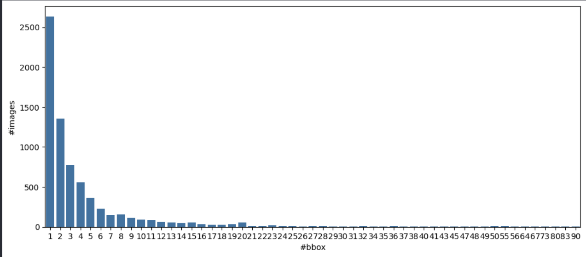

*Figure 1. Number of bounding boxes with number of images*

It is evident that this dataset is not clean. Numerous images contain multiple objects, which complicates the model's learning process.

**How many instances are there per each class?**

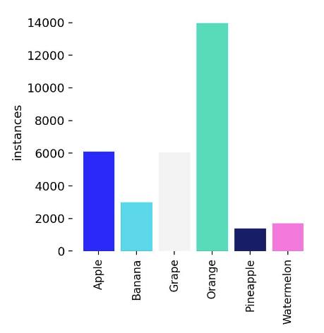

*Figure 2. Classes distribution*

It is evident that the dataset is imbalanced, with the Orange class being ten times more prevalent than the Pineapple class. This significant disparity can lead to model confusion and adversely affect its ability to accurately classify underrepresented classes.

## Model Selection

### Benchmarks

Object detection has been a research hot-spot for several decades. Consequently, there are several established benchmarks that enable us to select the most optimal model based on these standards. Namely [1][2]:

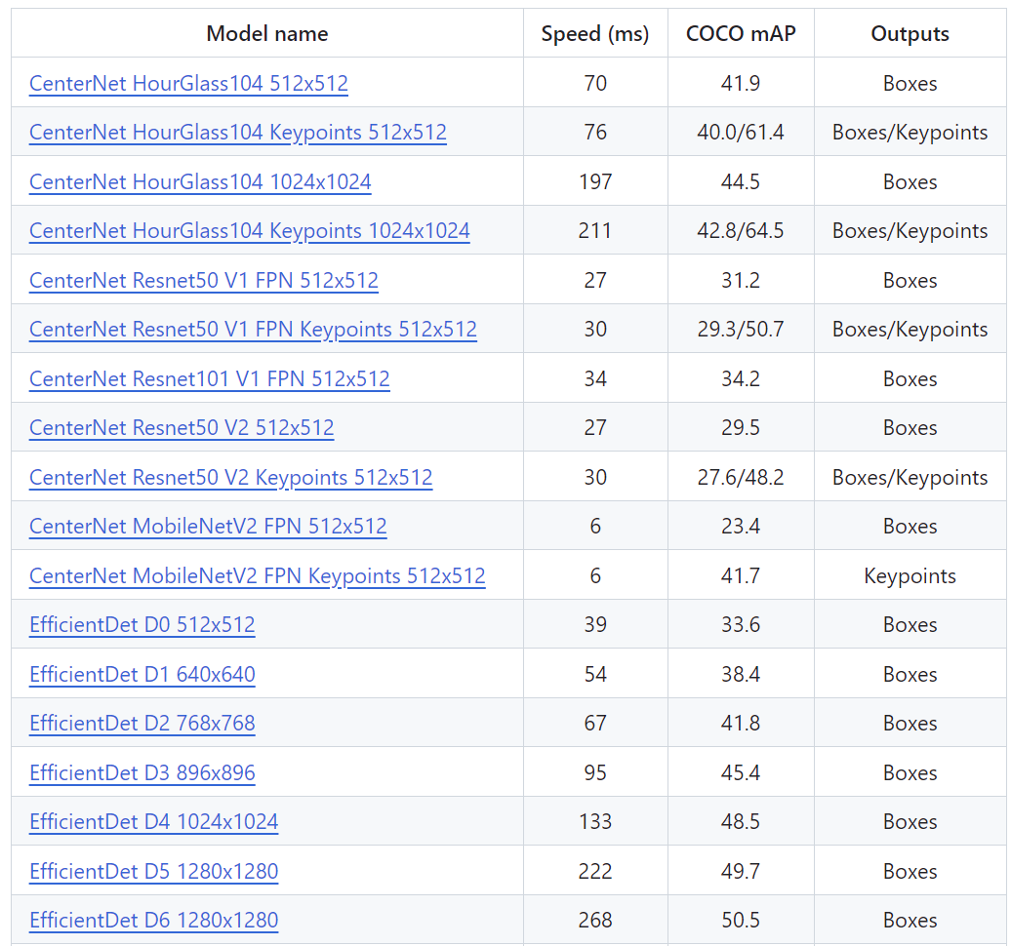

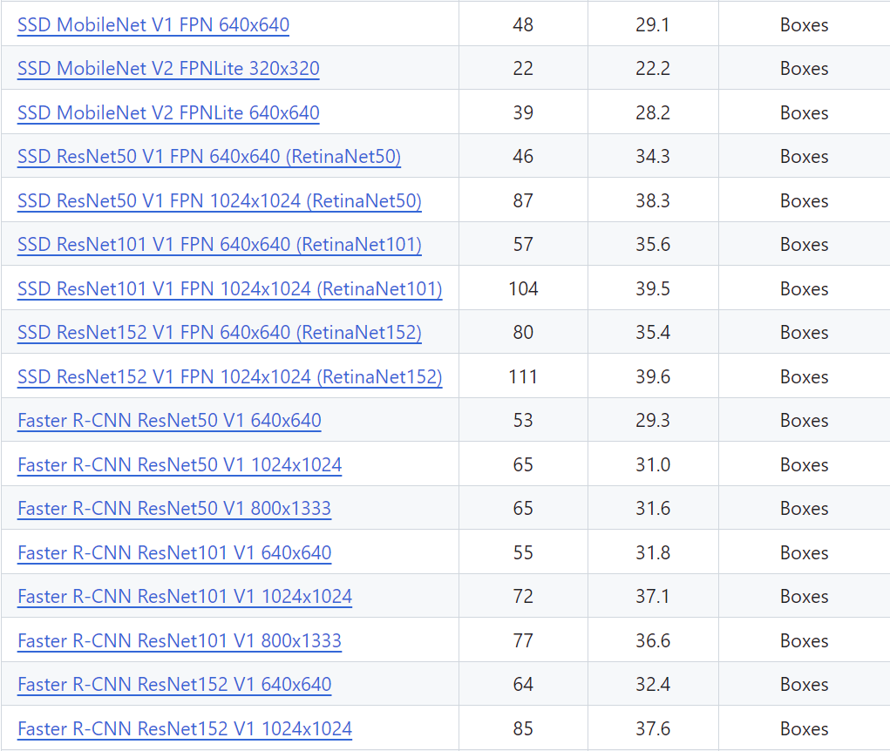

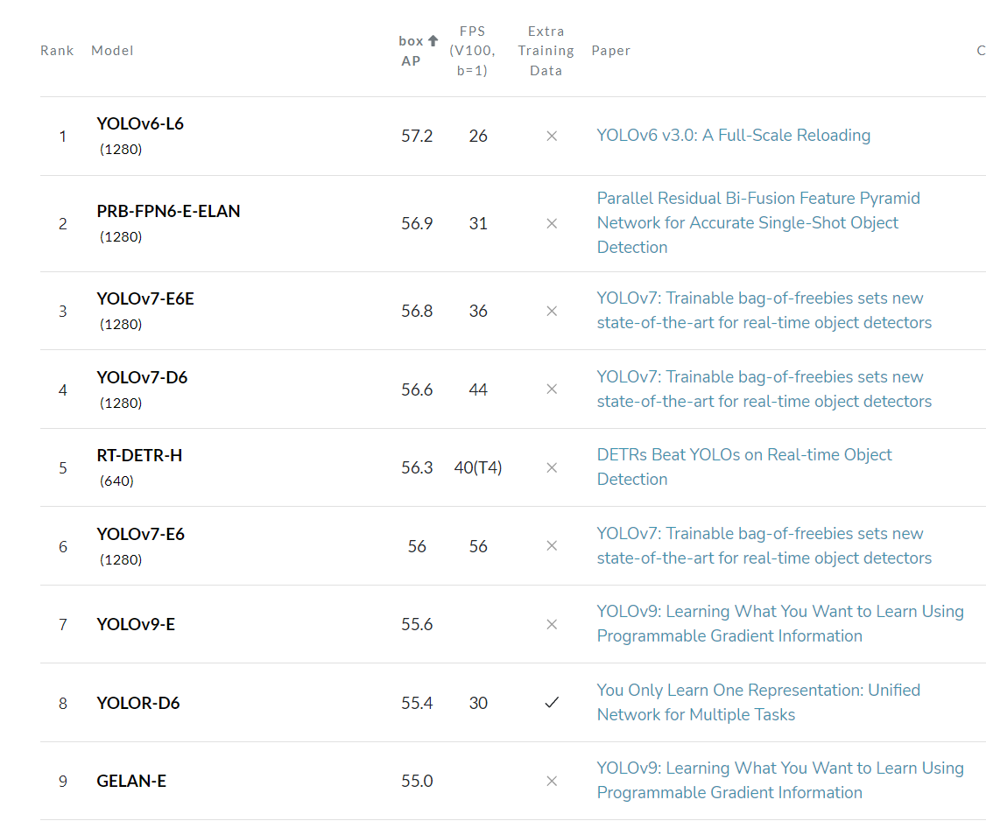

*Figure 3. List of object detection models benchmark*

In mobile applications, compactness and real-time performance are the two most critical criteria to consider. Some of the outstanding models that meet these requirements include CenterNet, MobileNet, EfficientNet, and the YOLO family.

Due to the following reasons:

* The dataset has a slight imbalance between classes
* The shape of the objects are simple
* The majority of them are multiple objects detection (not crowded).
* Testing purpose
* Compactness and real-time performance are the two most critical criteria

$→$**Therefore, I choose YOLOv8 as my main model as it has:**

* Well documented library
* Easy to implement and deploy
* Relatively lightweight and high-speed performance.

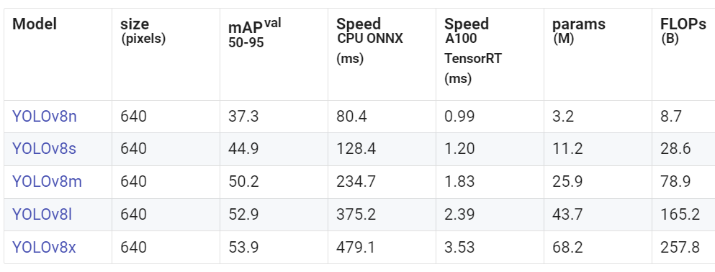

*Figure 4. YOLOv8 pretrained benchmark [3]*

In the following training section, I used to YOLOv8s pretrained version since it has a great balance between accuracy and speed that suit for mobile application.

## Training Model

The training section is performed via Google Colab environment. The train, test, val sets are divide as follow: **84% for train**, **11% for validation** and **5% for test**.

The training stage goes through **20 epochs**, **batch_size is 8** and training time is about **2.5 hours**. Given the simplicity of the dataset, and considering that the deployment phase is significantly more important in my opinion, I believe that the current level of training is sufficient.

Here are the final training statistics:

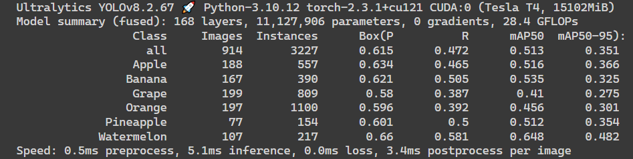

*Figure 5. Model trained summary*

## Validation

The loss:

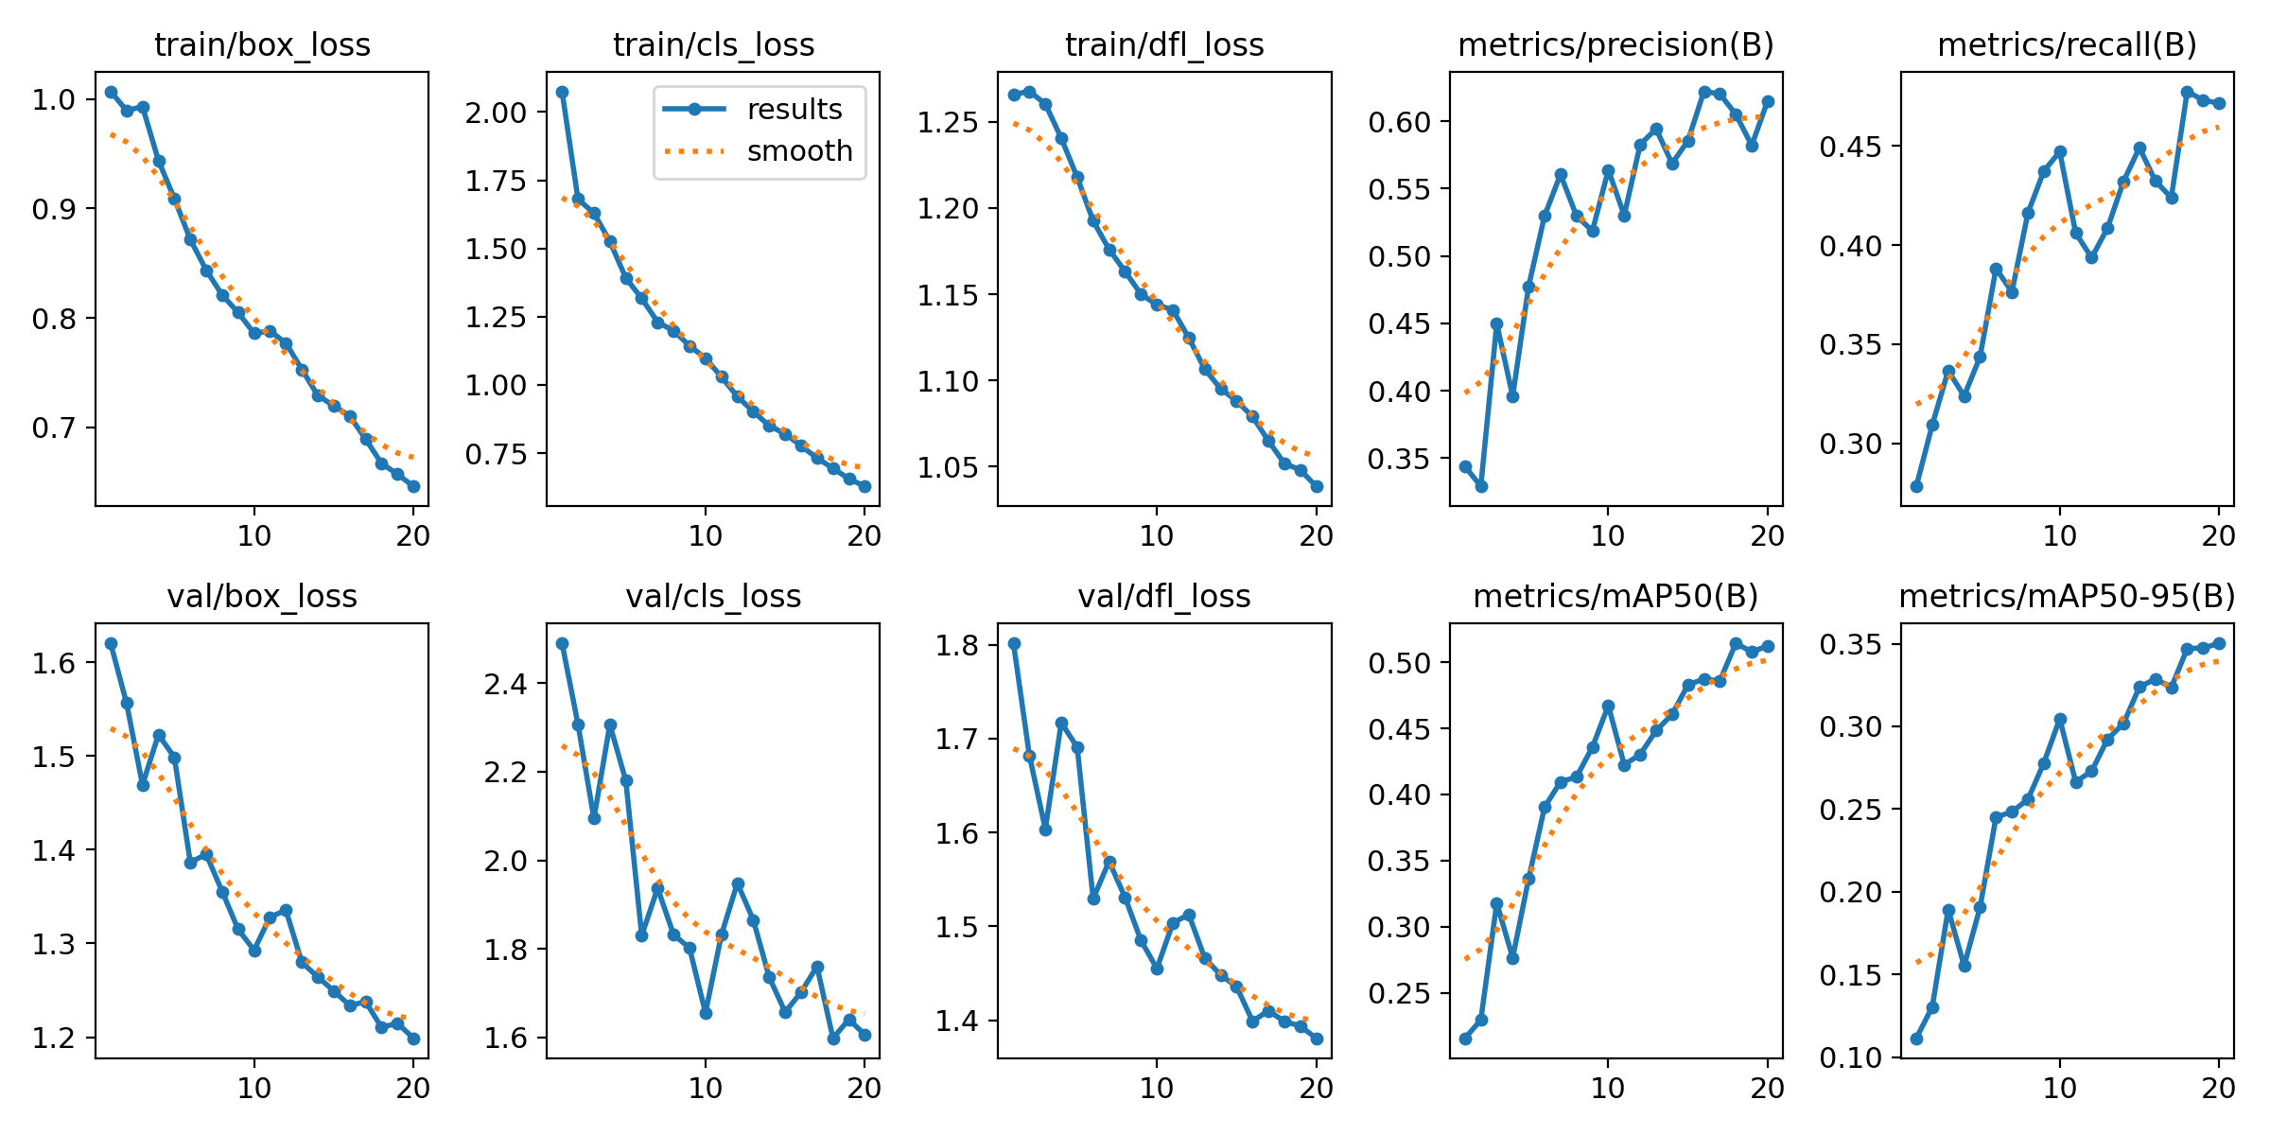

*Figure 6. Loss through training*

We can see that in general, the loss are converging while the precision and recall is increasing but gradually fluctuate.

The normalized confusion matrix:

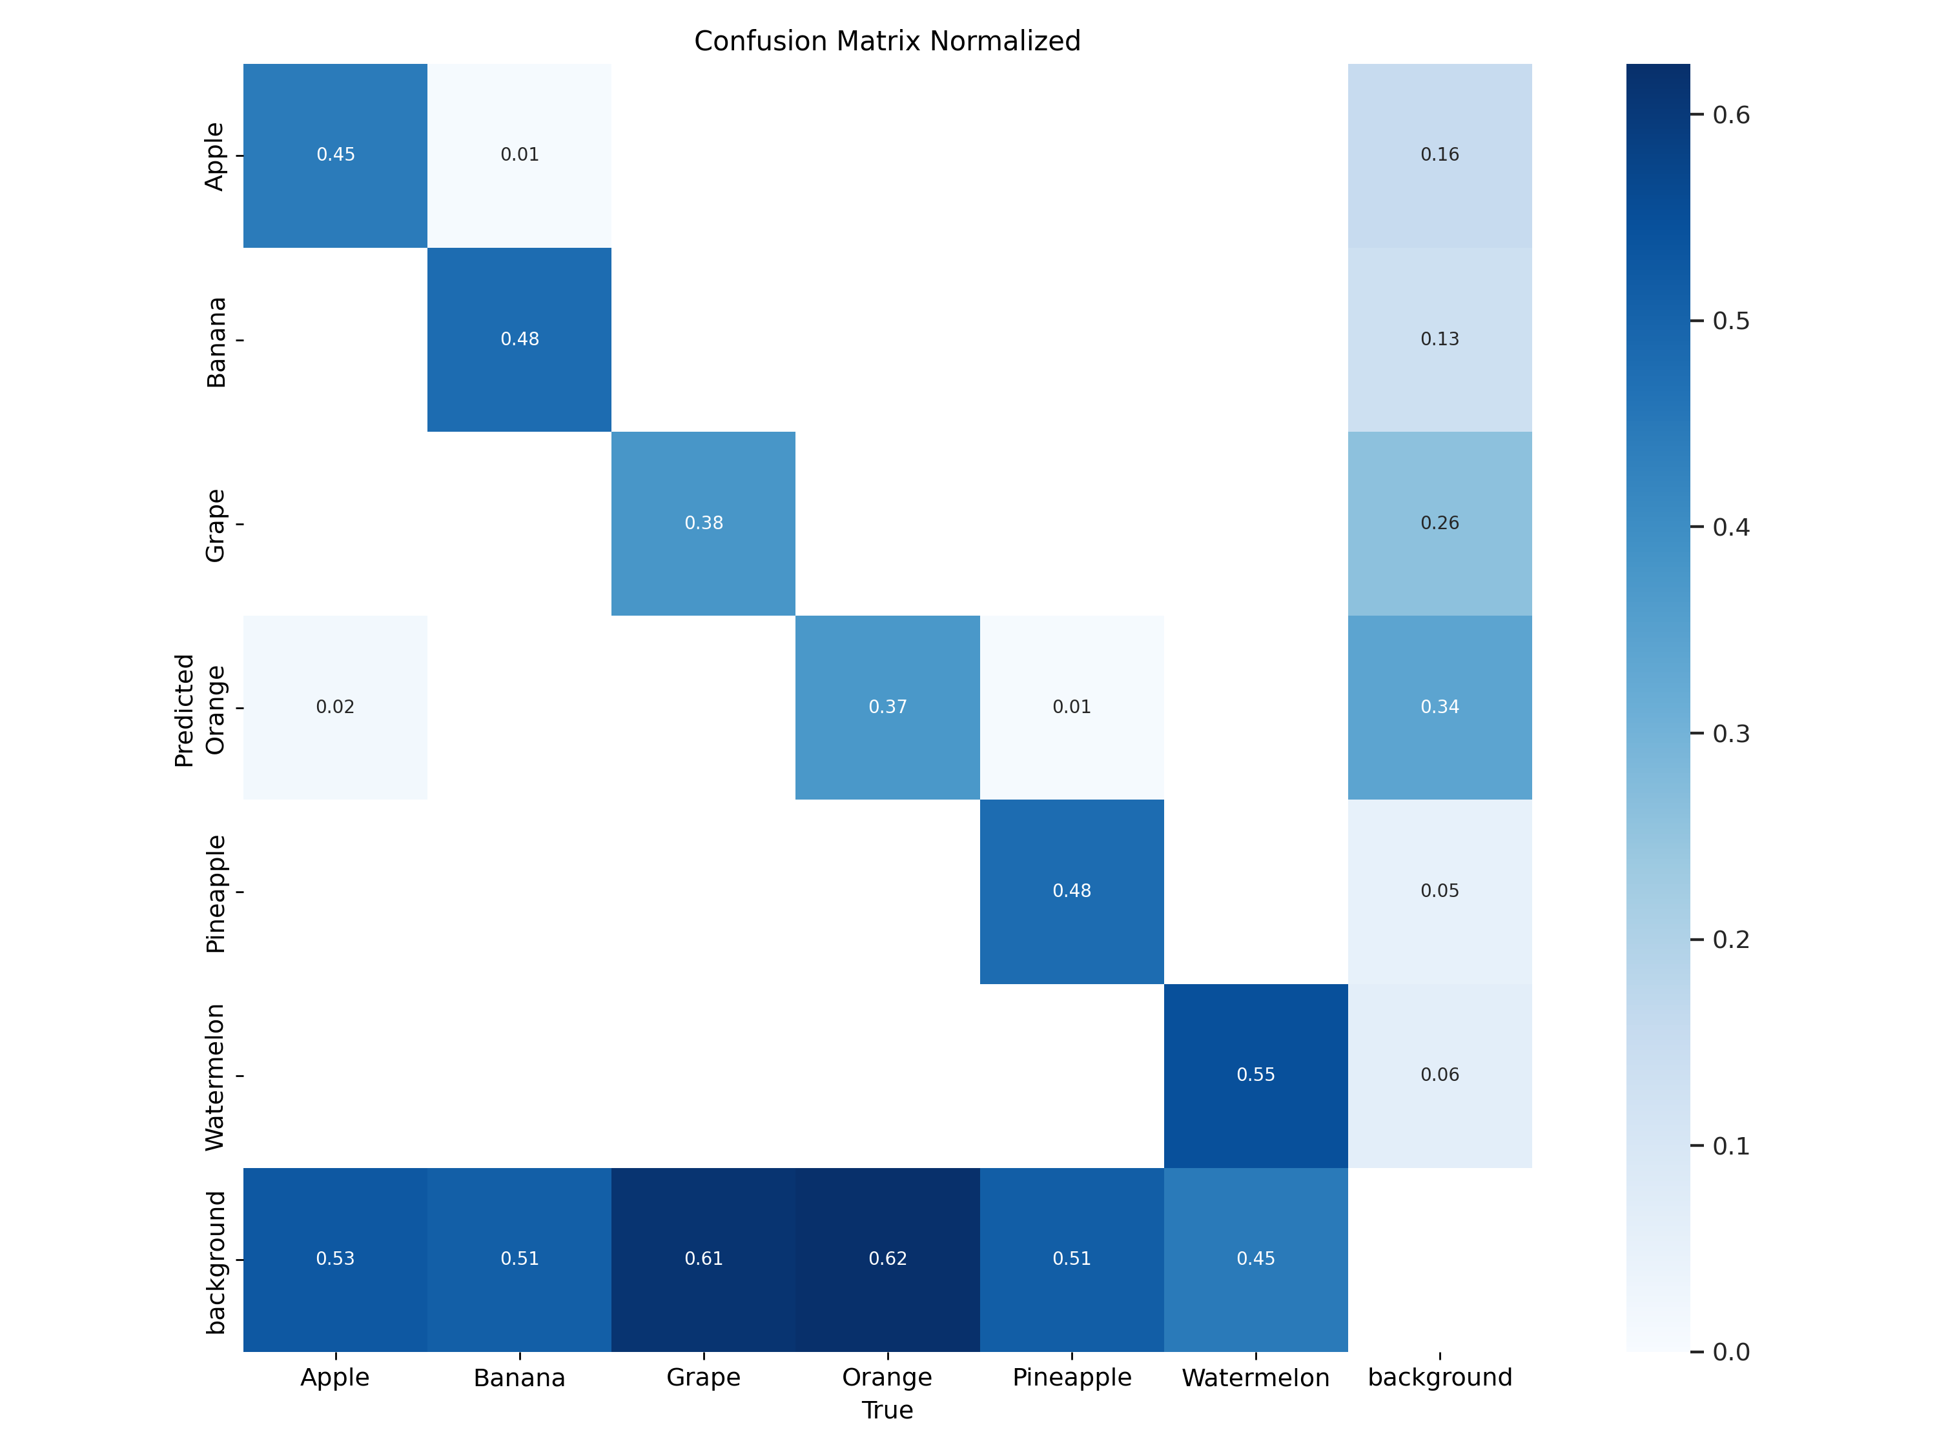

*Figure 7. Normalized confusion matrix*

The F1-Confidence Curve:

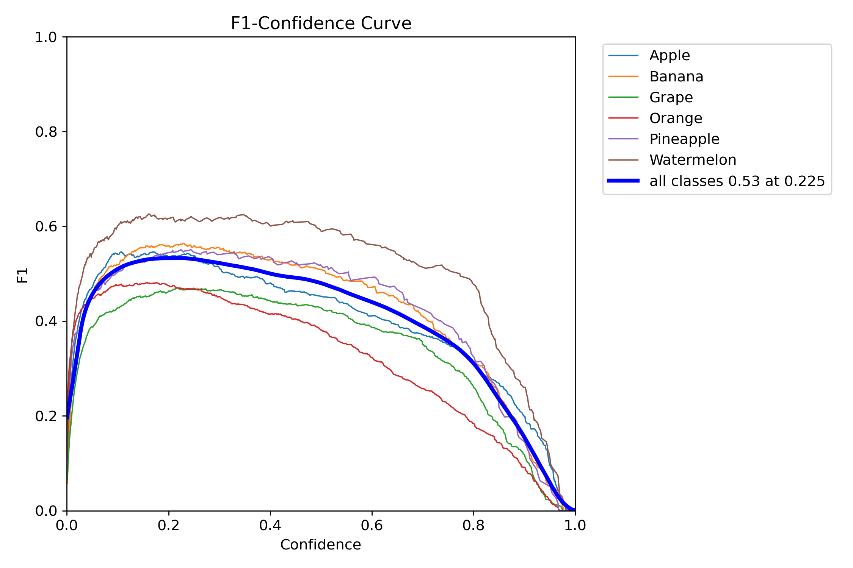

*Figure 8. F1 and Confidence curve*

The Precision-Confidence Curve:

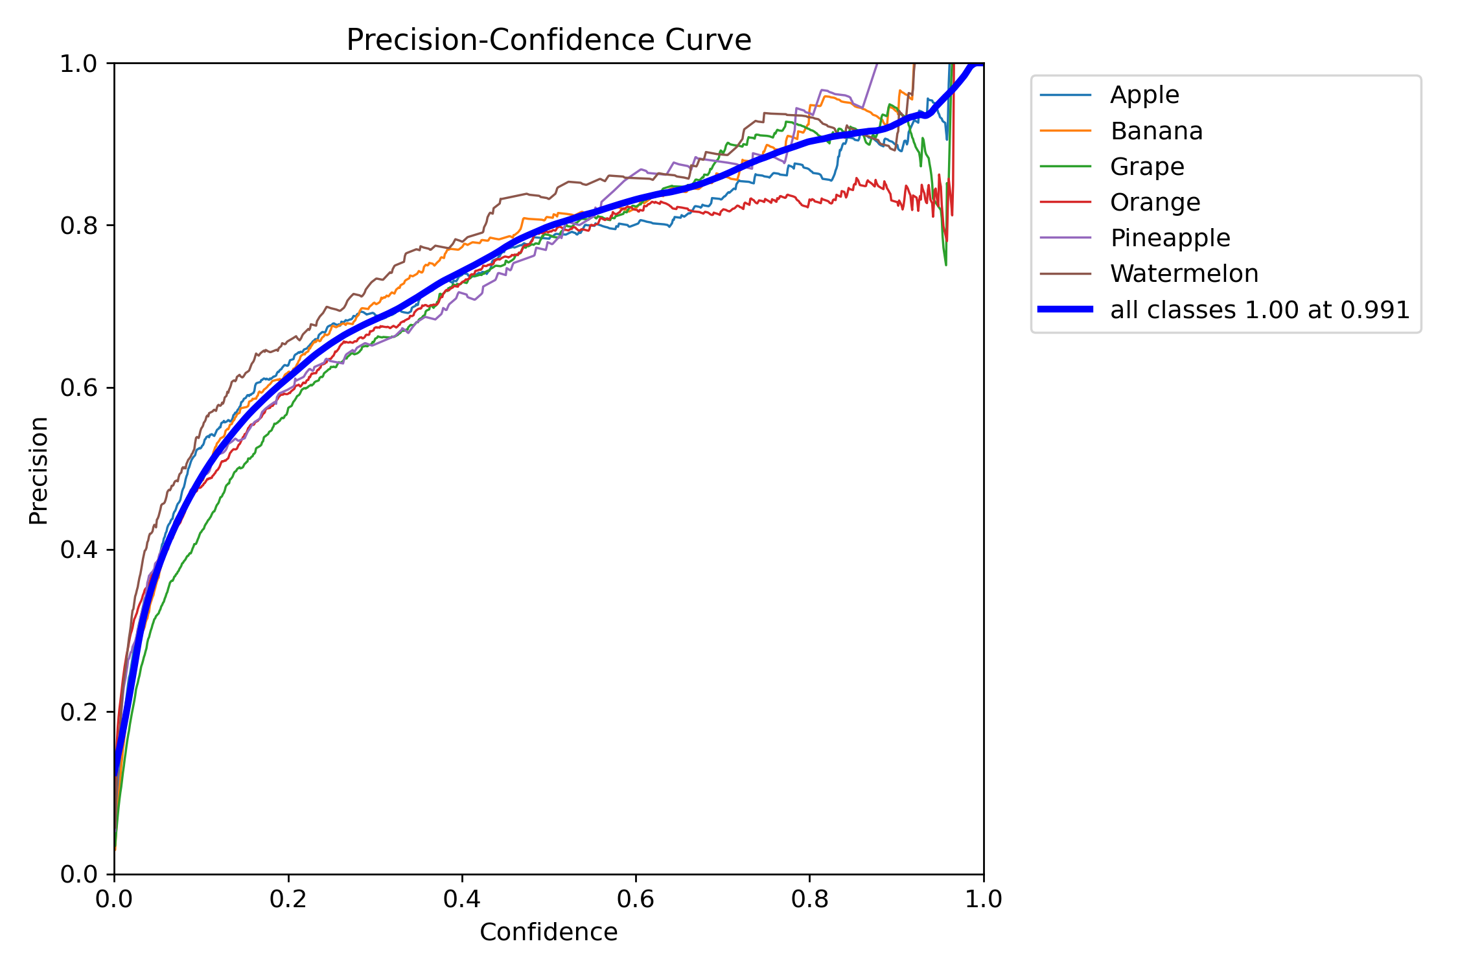

*Figure 9. Precision and Confidence Curve*

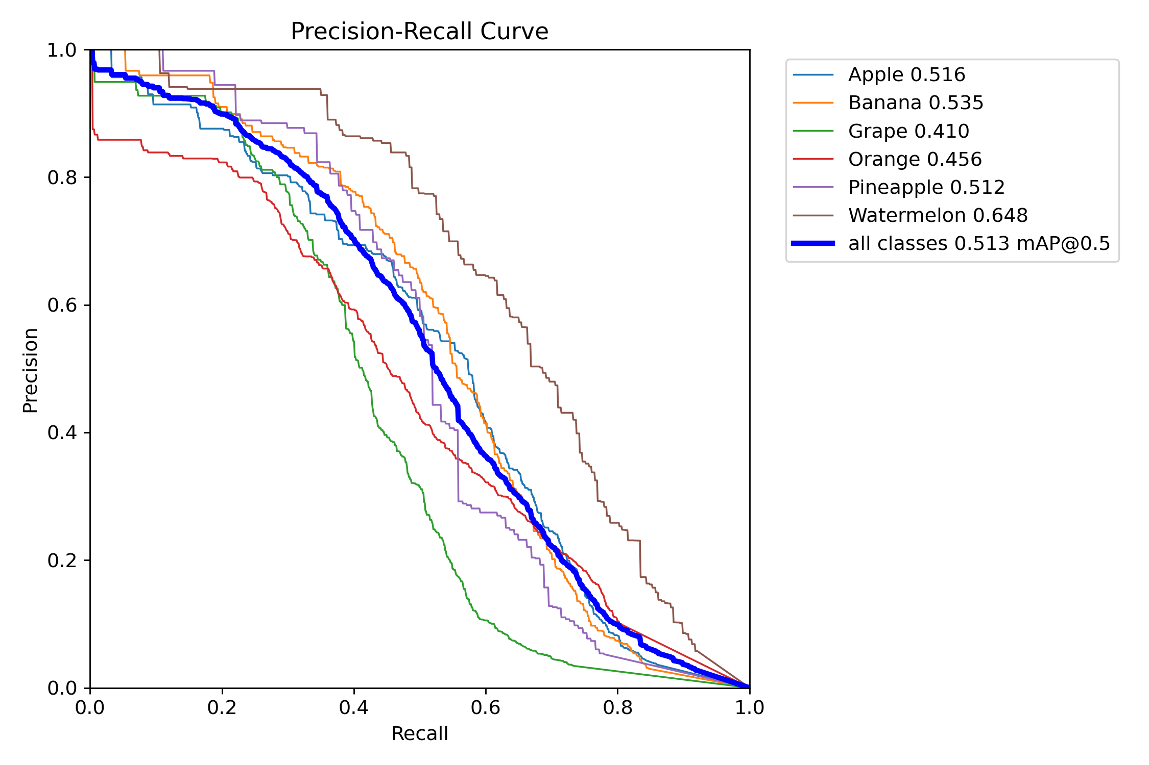

*Figure 10. Precision and Recall curve*

## Testing

The testing achieve a really good performance. For example:

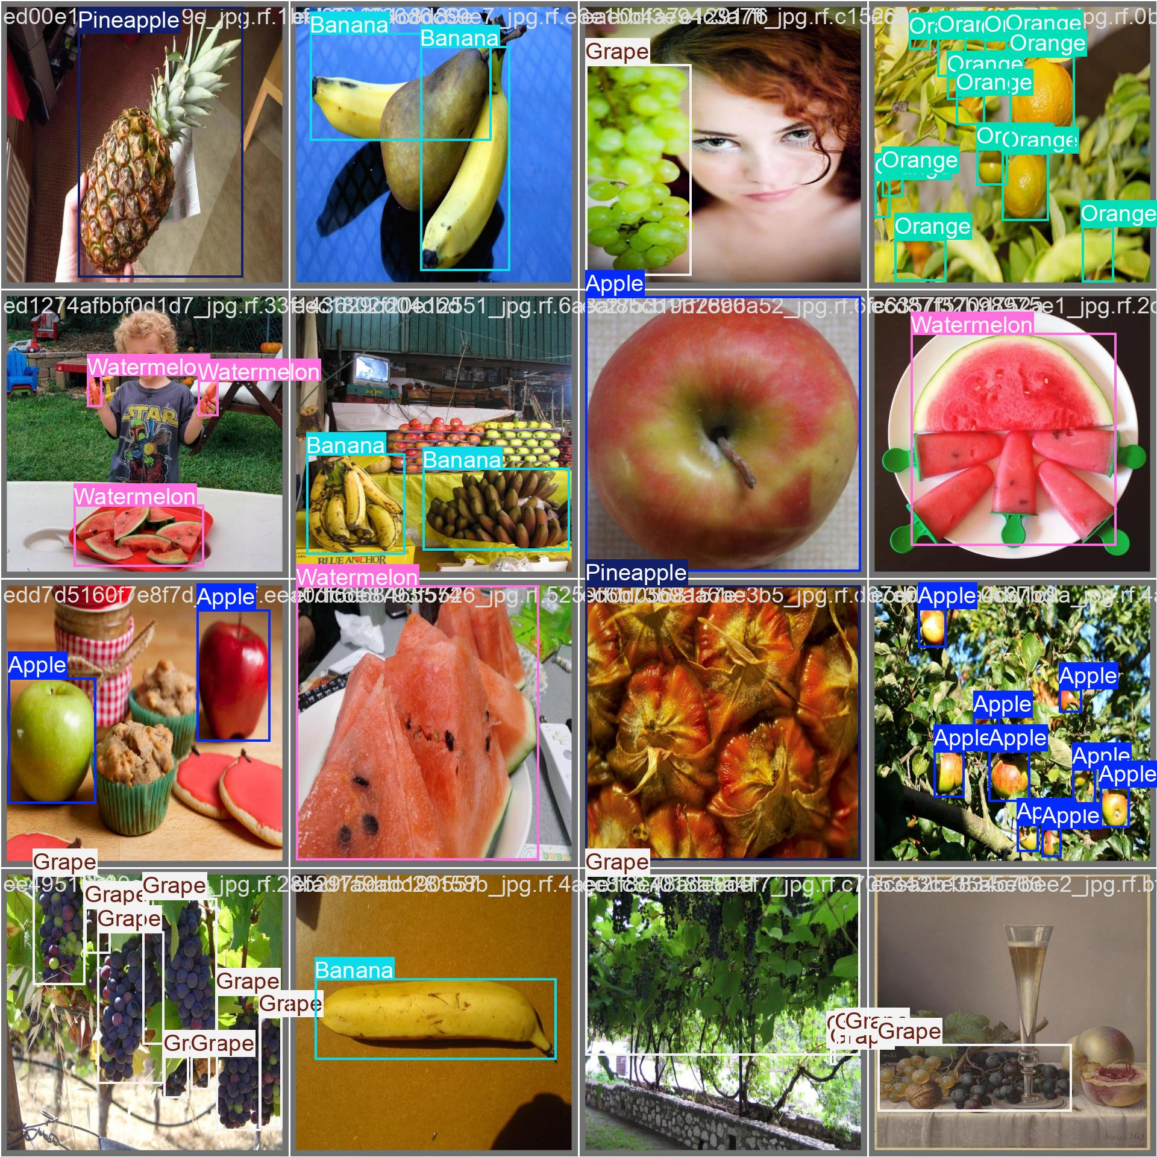

*Figure 11. Test images predicted*

## Deployment

For deployment, as previously mentioned, due to the absence of an Android device, I utilized the Colab environment to take advantage of its GPU resources. I employed JavaScript to stream the video and subsequently overlay bounding boxes on the streaming feed. Consequently, the bounding boxes may appear misaligned (see the Testing section for comparison).

Here is the sample operation:

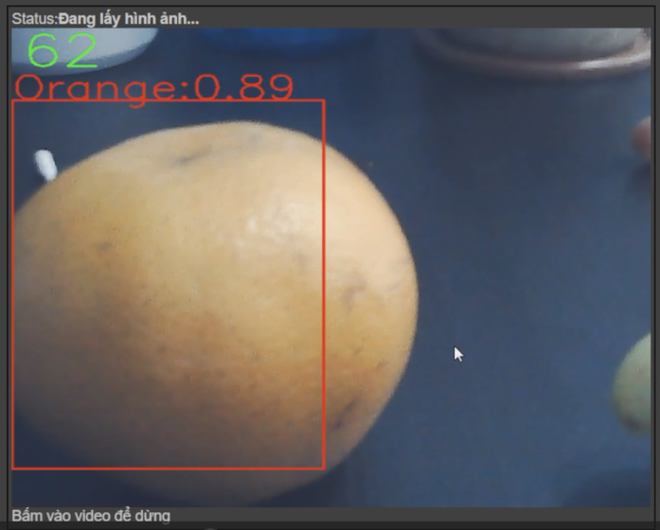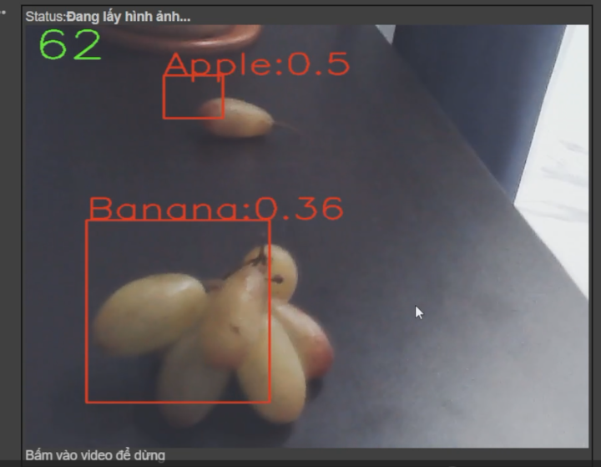

*Figure 12. Demo*

Some of the remarks:

* The accuracy of the orange is pretty high since it is the dominent class
* The accuracy for Grapes is bad since the grape in the dataset is a bit different (purple grapes) and the low resolution of my camera is also a potential reason
* **The FPS is really high (>60 FPS), it is real-time performance.**

**Video demo:** 